EXECUTE
Create a new pipeline and search for execute pipeline
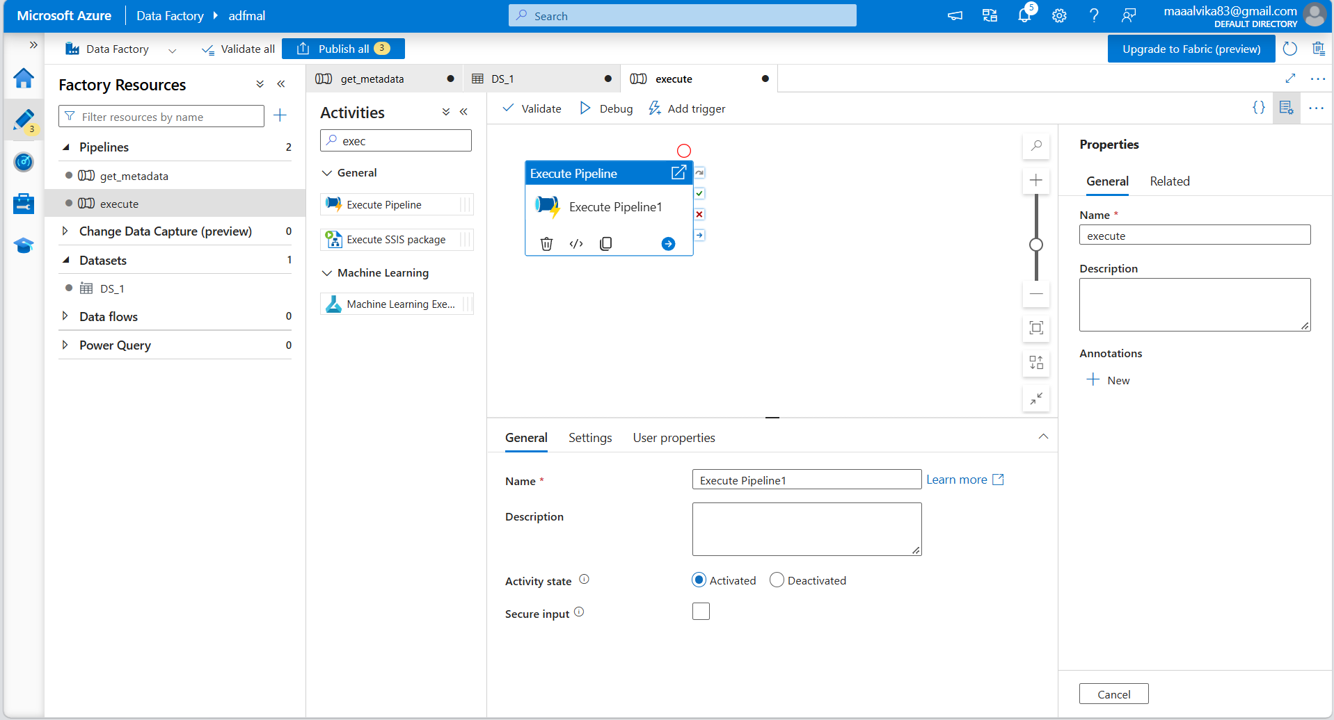
Create another pipeline for copydata and perform copy data activity
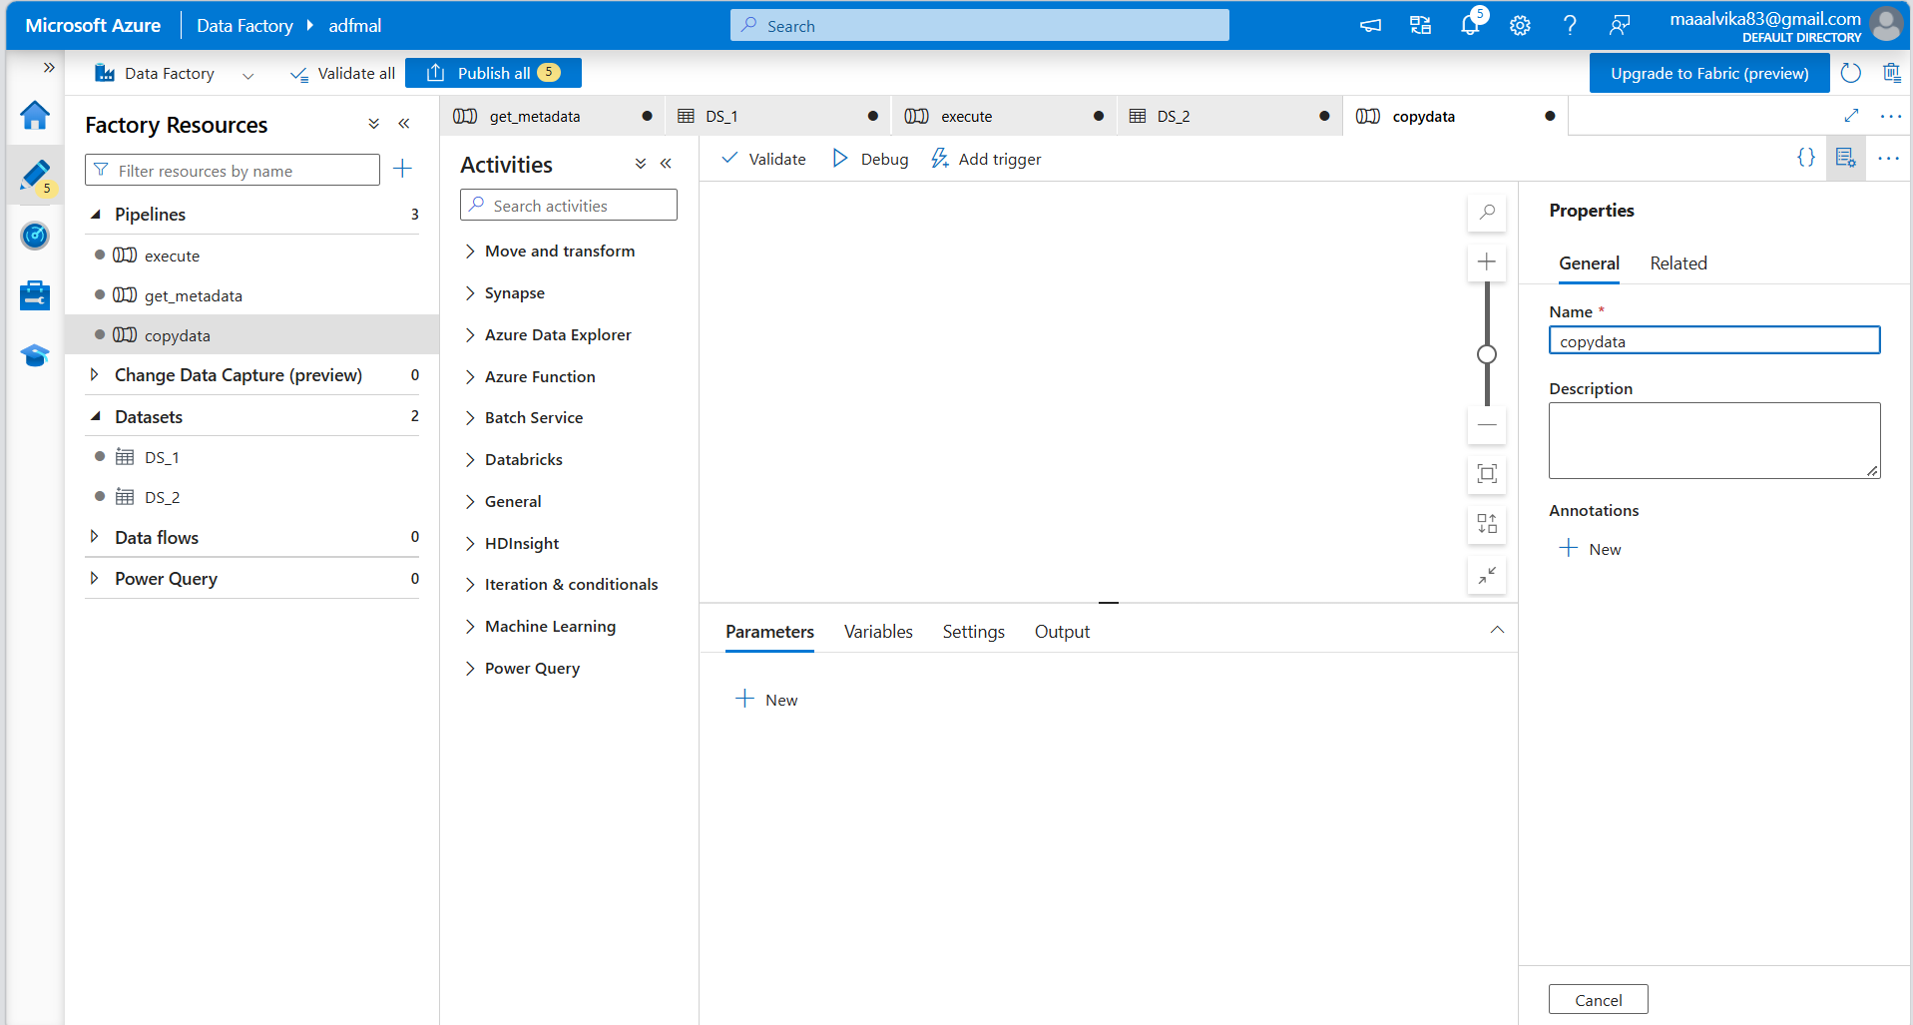

In settings, copydata pipeline is selected to be the invoked pipeline
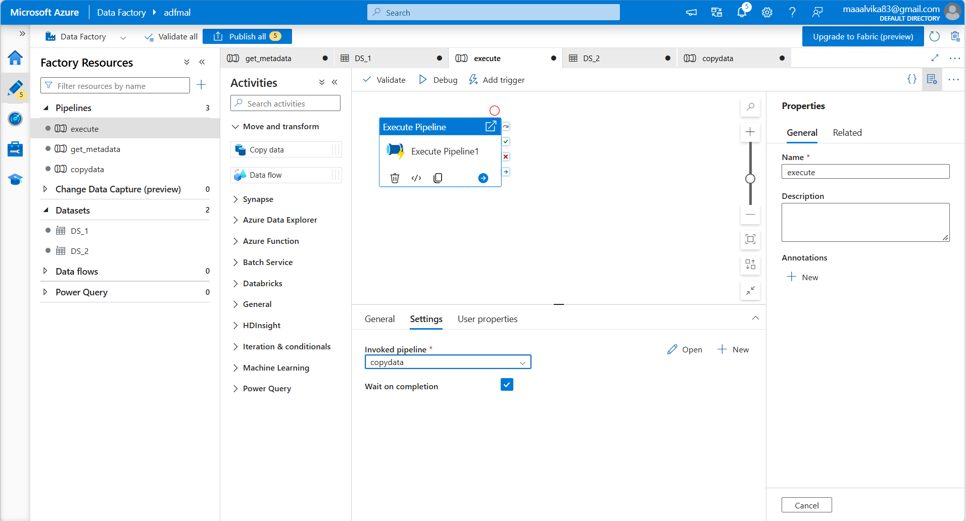
Validate and debug
